Paper Title* (use style: paper title)
*Note: Sub-titles are not captured in Xplore and should not be used

line 1: 1st Given Name Surname
line 2: dept. name of organization
(of Affiliation)
line 3: name of organization
(of Affiliation)
line 4: City, Country
line 5: email address or ORCID
line 1: 4th Given Name Surname
line 2: dept. name of organization
(of Affiliation)
line 3: name of organization
(of Affiliation)
line 4: City, Country
line 5: email address or ORCID
line 1: 2nd Given Name Surname
line 2: dept. name of organization
(of Affiliation)
line 3: name of organization
(of Affiliation)
line 4: City, Country
line 5: email address or ORCID
line 1: 5th Given Name Surname
line 2: dept. name of organization
(of Affiliation)
line 3: name of organization
(of Affiliation)
line 4: City, Country
line 5: email address or ORCID
line 1: 3rd Given Name Surname
line 2: dept. name of organization
(of Affiliation)
line 3: name of organization
(of Affiliation)
line 4: City, Country
line 5: email address or ORCID
line 1: 6th Given Name Surname
line 2: dept. name of organization
(of Affiliation)
line 3: name of organization
(of Affiliation)
line 4: City, Country
line 5: email address or ORCID

ADVERTISEMENT ASSISTANT

PROBLEM STATEMENT:
- Instagram first came out with their Sponsored Ads posts that were allowed to show up on our personal feeds back in 2013. Since then not only have the ad frequencies increased but have also become increasingly more redundant, sometimes pretty misguided.
- These increased numbers of advertisements on user feeds have not only served as a source of irritation but also an inconvenience to see ad after ad whilst scrolling through a personal feed of content people choose to follow and keep up with.
- To decrease the number of Advertisements we propose an Advertising assistant. What we want to do is, take existing images that users subscribe to, content that the user wants to see and try imbibing advertisements seamlessly in these images.
- We try finding background features/shapes that can be replaced with logos of brands that are to be advertised. Thereby effective marketing happens along with more meaningful reach to target demographic.
- We plan to do this primarily superficially, just finding matches that look aesthetically pleasing in said picture and recommend a bunch of logos based on shape aspect ratios, shape features (both of logos and background mask of image) etc. We are yet to define a well set of parameters to recommend based on.
- We can further apply this to videos, where this sort of image analysis can be done on frames of videos and seamlessly insert advertisements within vidoes which would tackle another problem of annoying youtube ads.

PROPOSED SOLUTION:
- To combat the aforementioned problem, we plan to seamlessly insert Advertisements in pictures in the background, without taking away from the main subject but at the same time be noticeable at first glance.
- To do this, we first identify the shapes in an image. Once we are able to identify shapes within said image, we already have our dataset with a bunch of logos.
- We group these logos based on shapes and map them. We then extract the particular identified shape set from the logos and see which would be the best fit.
- For this we take into many shape parameters like aspect ratio, centroid location, diameter, edge length etc. after analysing the shapes we then analyse the color schemes. The general color schemes are analysed here, to understand the dominant colour present in the logo or detected region in the image. This is important in the process of recommending aesthetically similar logos to overlay.
- Once we figure the best parameters for determining the best logo to fit in based on shape and color, we recommend several logos to fit into the image that would optimise marketing and advertising campaigns.

VISUALISATIONS:
- The goal of the project is to overlay aesthetically similar brand logos onto similar shaped regions in an image
- To find logos with a similar colour scheme as the region identified, it is important to understand the dominant colour groups in brand logos
- The following images are images of logos in our dataset and their corresponding dominant colour families. The dominant colour groups were found by using k means clustering, using the RGB values of the pixel coordinates in the logo image as data points.
- A pie chart representing the dominant colour groups where each sector is coloured with the centroid value of the cluster and the labels of the sectors of the pie chart are the hexadecimal colour codes

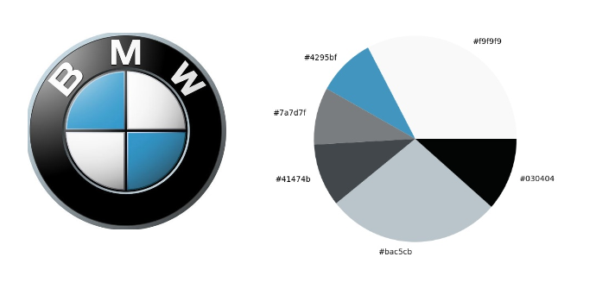

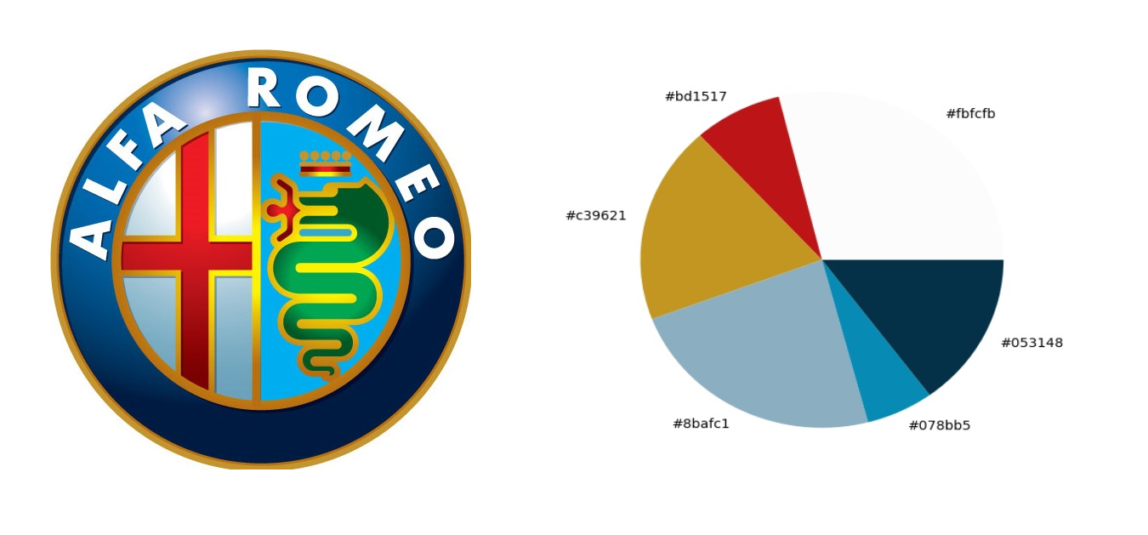

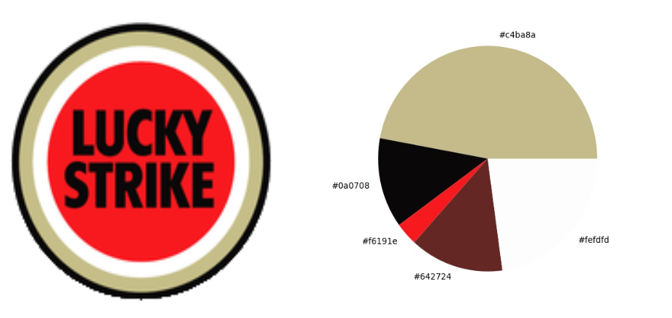

LITERATURE SURVEY:
VideoSense: A Contextual In-Video Advertising System, IEEE , 2009
This paper forms the baseline of modern in-video advertising solutions. With a novel approach to insert ad-videos within original videos based on content discontinuity and content attractiveness and relativeness, this paper also achieves remarkable results during the experimentation setup.The paper claims that ad-insertion is a non-linear integer programming problem and this is something we agree with. It highlights the differences between object-level advertising and segment-level advertising and proposes solutions to tackle them both. Our key takeaway is the approach taken for object level advertising wherein images or products or brands to be advertised are placed on static non-contributing objects in frames within videos(in our case, images).The approach taken is to first identify insertion points in videos with respect to lesser intrusiveness and attractiveness. The context of the video is analysed through several different methods, including analysing the surroundings of the webpage containing the source video. Contextual relevance is also analysed based on local visual-aural relevance between insertion points. The extracted context is then compared with the context of said given ad-videos and the most appropriate one is chosen for in-video advertising. This forms the basis for the segment level advertising approach. In object-level advertising, at the insertion-point, the frame of the video is taken into consideration and the least desirable object is overlayed with the image of the ad that matches the context.The paper also proposed a novel ‘multi-modal’ approach for evaluation. The evaluation was set up for different aspects of the proposed solution. For instance, different evaluation strategies were used for measuring the contextual relevance, measuring the content intrusiveness at the different insertion points, measuring the relevance of the inserted ads and so on.
The limitation is this paper proposes object-level advertising as simply an extension to their original solution and does no justice in highlighting the technical details for the same. They also claim to need better matching between ads and videos based on context.
CAVVA: Computational Affective Video-in-Video Advertising , IEEE, 2014
This paper highlights the drawback of traditional outdated ad-insertion methods and the need for improved approaches to tackle the advertising solution. This paper builds on the idea ad approaches suggested by Videosense. They also claim that with their fine-tuned model; they obtain a good balance between conflicting goals of minimizing user disturbance due to ad-insertion while enhancing the user engagement with the ad itself.This paper also proposes certain parameters to be included while developing the recommendation system to give better results for the task at hand. The experimental evaluation setup as explained in this paper is also pretty unique and worth considering. They analyse the significance of their approach by measuring subjective user experience and the ability for a user to recall a brand later on.While this paper builds upon the baseline Videosense paper, it still does not provide us with a concrete solution for object-level advertising. The eye-tracking approach is also something that isn’t feasible.
Embedding user preferred advertisement in video playback in ecommerce, International Journal of Pure and Applied Mathematics , 2018
The key-takeaway from this paper is ad-insertion techniques and benefits of such techniques from an ecommerce perspective. The implementation and the model proposed by them is a real-time framework that is based on mining data based on user’s behaviour on ecommerce websites.
Although this approach is widespread and can be seen in implementation already with the larger ecommerce companies, this paper gives an idea of how such an approach can be implemented for our project.
Edge Detection
For the purpose of edge detection, we implement the Holistically-Nested Edge Detection model using PyTorch. The model itself has been trained on the bsds500 image dataset. The need for the model is to produce outline/edges for images that are passed. Through experimentation, we found that this model performs significantly much better than Canny edge detection and other models of the sort. The novel approach for edge detection was implemented in caffe(deep learning framework in C++) but we have used the PyTorch implementation for the same. The edge detection algorithm itself is capable of generating multi-level features and has multiple stages with different strides, so as to capture the inherent scales of the map/image. It implements the VGG architecture with a few modifications. The output produced is a black image with white edges which we invert for the purpose of clear shape detection. It is also superior in terms of the time required for processing the image which through our experimentation was approximately 0.5 seconds on GPU.

The shape detection algorithm scans the entire black-white image passed through the edge-detection model. Through experimentation, we discovered that the previous step was required to produce more accurate results. The algorithm works with pixel identification and allows us to broadly classify shapes into 7 distinct categories. Bounding Boxes are drawn on the region where the shape is detected and the co-ordinates of the top left corner of the detected shape are passed along with the width and height of the bounding box. This information is taken benefit of in the next stage for region analysis for overlaying suitable logos onto the corresponding image.
At the end of this pre-processing phase, the results produced are the 2-dimensional co-ordinates of the two largest shapes detected within the image and the width and height of the bounding box that corresponds to the same which is written into a dataframe.

Context-Dependent Sentiment Analysis in User-Generated Videos, Association for computer linguistics, 2017
This paper talks about multimodal sentiment analysis in videos. They talk about the utilization of a LSTM- based model that enables to capture contextual information from surroundings. This is beneficial to us to understand the context of an image based on objects within the image and surrounding text(if any). They claim to have 5-10% performance improvement over state of the art and high robustness to generalizability. The key takeaways of this paper are the multimodal approach and the characteristics of the 3d-CNN(Visual feature extraction) and text-CNN they have implemented for context analysis.The paper reports the performance of the different type of LSTM architectures available. The best performing model is the bc-LSTM model scoring the highest in each test case as generated by the authors.
Patent : INTERACTIVE PRODUCT PLACEMENT SYSTEM AND METHOD THEREFOR
The patent describes the process of static ad placement techniques in videos at pre-defined cue points. These ads are mostly in the format of images that are similar to the Video object level advertising approach. This patent talks about placement of such images at these cue-points without having any contextual analysis method. These ads however are capable of rerouting users to other landing pages where these products are being sold or brand marketing pages. They take away from this patent is the cue point approach. However, the major difference is while these cue points are static and are pre-defined, out approach involves these cue points being dynamic. The images inserted as ads itself shall be recommended based on a certain degree of contextual analysis.
- To combat the aforementioned problem, we plan to seamlessly insert Advertisements in pictures in the background, without taking away from the main subject but at the same time be noticeable at first glance.
To be able to do this, we first produce an annotated logo dataset. The user is allowed to choose the logo he would like to insert and based on the tags associated to the logo chosen, we find the most similar image from an annotated image dataset. Once we have identified the said image, we perform colour analysis on the pre-determined regions of the image and recommend the appropriate region for logo insertion where it would be most seamless, effective and aesthetic.
To obtain out datasets, it is essential that we first pre-process raw data to model usable format. This would include the pre-processing phase where we select two regions per image based on largest area available for logo insertion in the image. The colour characteristics of the region are then written into a dataset to make it easier for real-time processing.

